Edit Szabo is a designer and sculptor who creates architectural, functional and conceptual ceramic works. She has expertise in such specialty areas as water features, ceramic and masonry tile stoves, functional cladding systems, porcelain items, street furniture and sculpture. She conceives her work not as objects placed in space, but instead forming an integral part of their environment, shedding light on the conceptual organization of a space. She has won awards for her Adessys line of ceramic acoustic spatial dividers and her paraphrased baroque ceramic tile stove for a baroque castle in Hungary. Her newest work is the TAME collection of ceramic seatings offers a refreshing variation to mass-produced furnishings with refined, functional sculptural pieces for indoor and outdoor use.

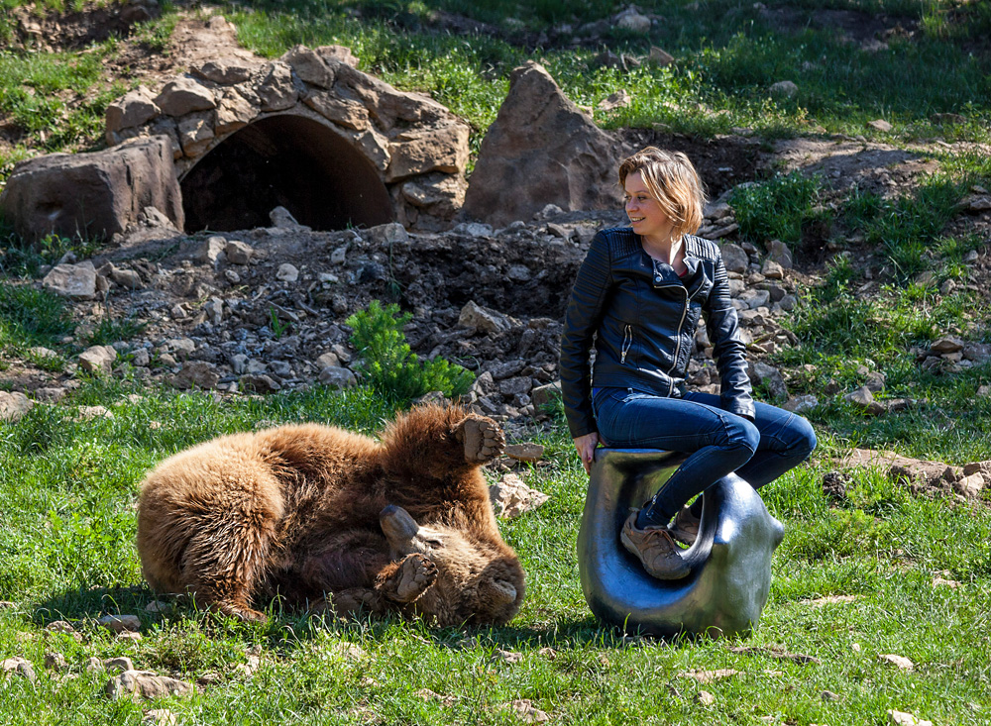

“Early in my art studies, I recall standing before hundreds of flames spitting out from an imperfectly built brick crust in which my large sculpture was fired, and felt a deep connection with the ceramic material being born. Controlling the power of fire and developing an ability to transform material has fascinated me ever since. From that moment my profession and goals were established for good. From this early “alchemist” phase also came my interest in innovation, leading me to design acoustic covers, furniture, and other objects; the focal point of my interest was to find the strange connection between space and object, voice and form, light and touch. I know now that I am looking for a balance and connection in the complexity of the dependencies between various media.”
TAME COLLECTION

The TAME series of ceramic seatings, coffee table and planter offers a refreshing variation to mass-producted furnishings in refined, functional sculptural pieces. The FOX, BEAR, DEER and WOLF pieces are part of the TAME furniture series. The many possible arrangements of the organic furniture forms recall wild animals that have been tamed. Produced in small runs, the pieces are made of long-lasting, durable, high-quality materials, making them suitable for indoor or outdoor use. When used indoors, they can house electronics such as WiFi, chargers, and speakers as well as heating elements. The line will continually expand with more seating and other functional accessories such as planters and bins.

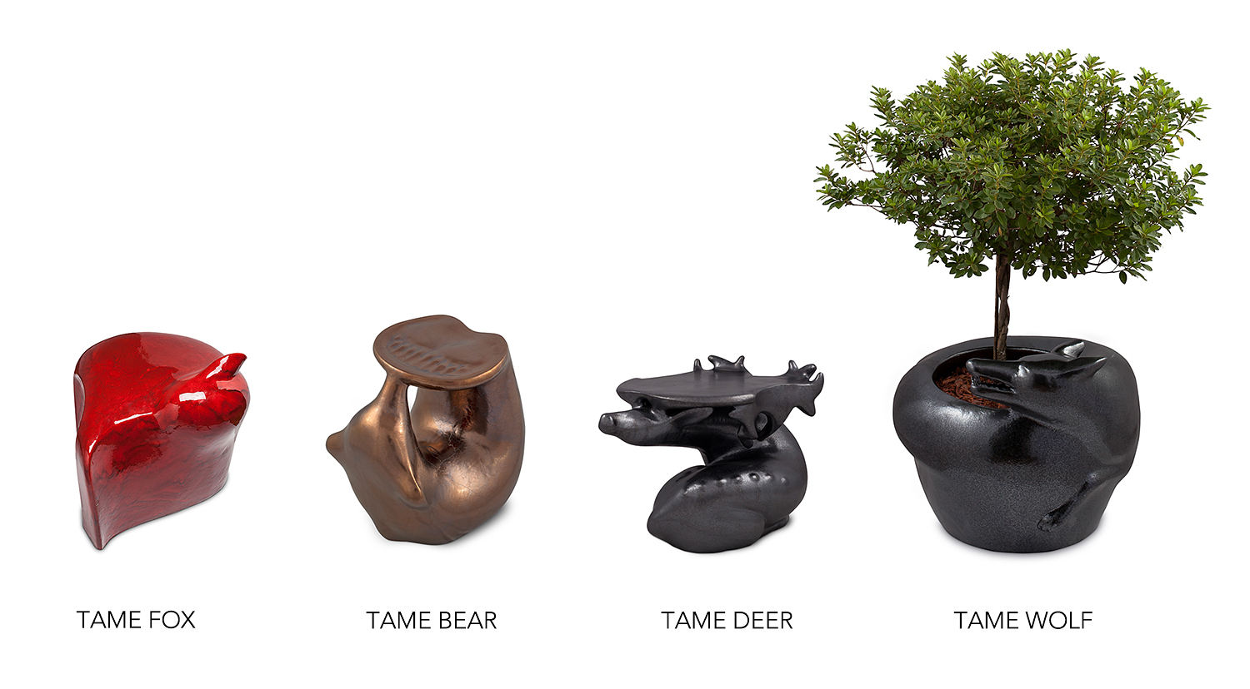

TAME WAS CONCEIVED TO BE USED CREATIVELY
The FOX and BEAR seatings, the DEER table and the WOLF planter are suitable for indoor and outdoor use, in private or public spaces. Equally appropriate for sitting in the living room and around a campfire, they are both weather and fire resistant. As side tables they travel in packs, or guard our dreams as bedside tables. When heated they breath life into winter gardens, children’s rooms, bathrooms, or even the living room. Their ease of care and cleaning make them ideal for bathrooms too.

THE TAME PACK IN SPACE
TAME animals arranged in packs make joyful spectacles for events or festivals thanks to their sculptural forms and rounded, inviting shapes. The pieces of the TAME series organize space by delineating areas and suggesting direction. They prompt us to find the arrangement most personally ergonomic, facilitating ideal spatial relationships in a group environment.

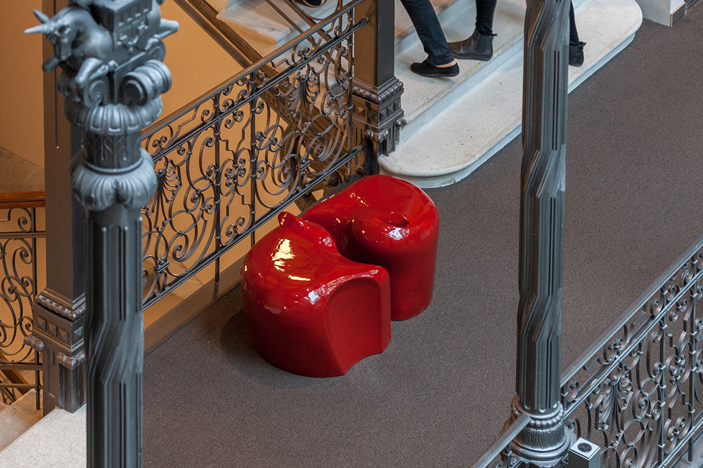
The TAME FOX seating prefers to be arranged in packs, the pieces linking together in any arrangement. One FOX alone is a seat for one person, but two snuggled together they form a seat for two. They can be fitted with wheels to make rearranging the pieces easy.

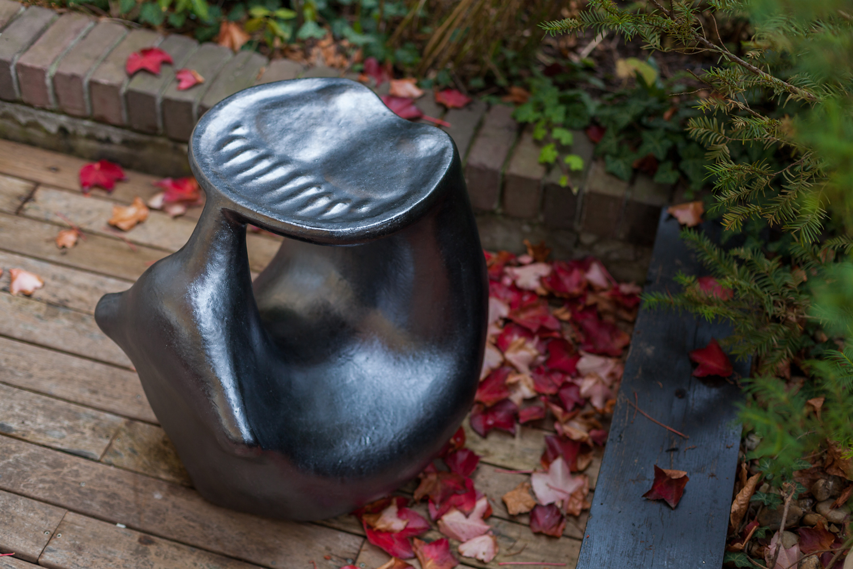
The somersaulting TAME BEAR can be placed on any of its sides to form a comfortable seat: two sides make a lower chair for children, and two a higher one comfortable for adults. The BEAR cannot be perturbed – the contours of its body always ensure a stable footing.

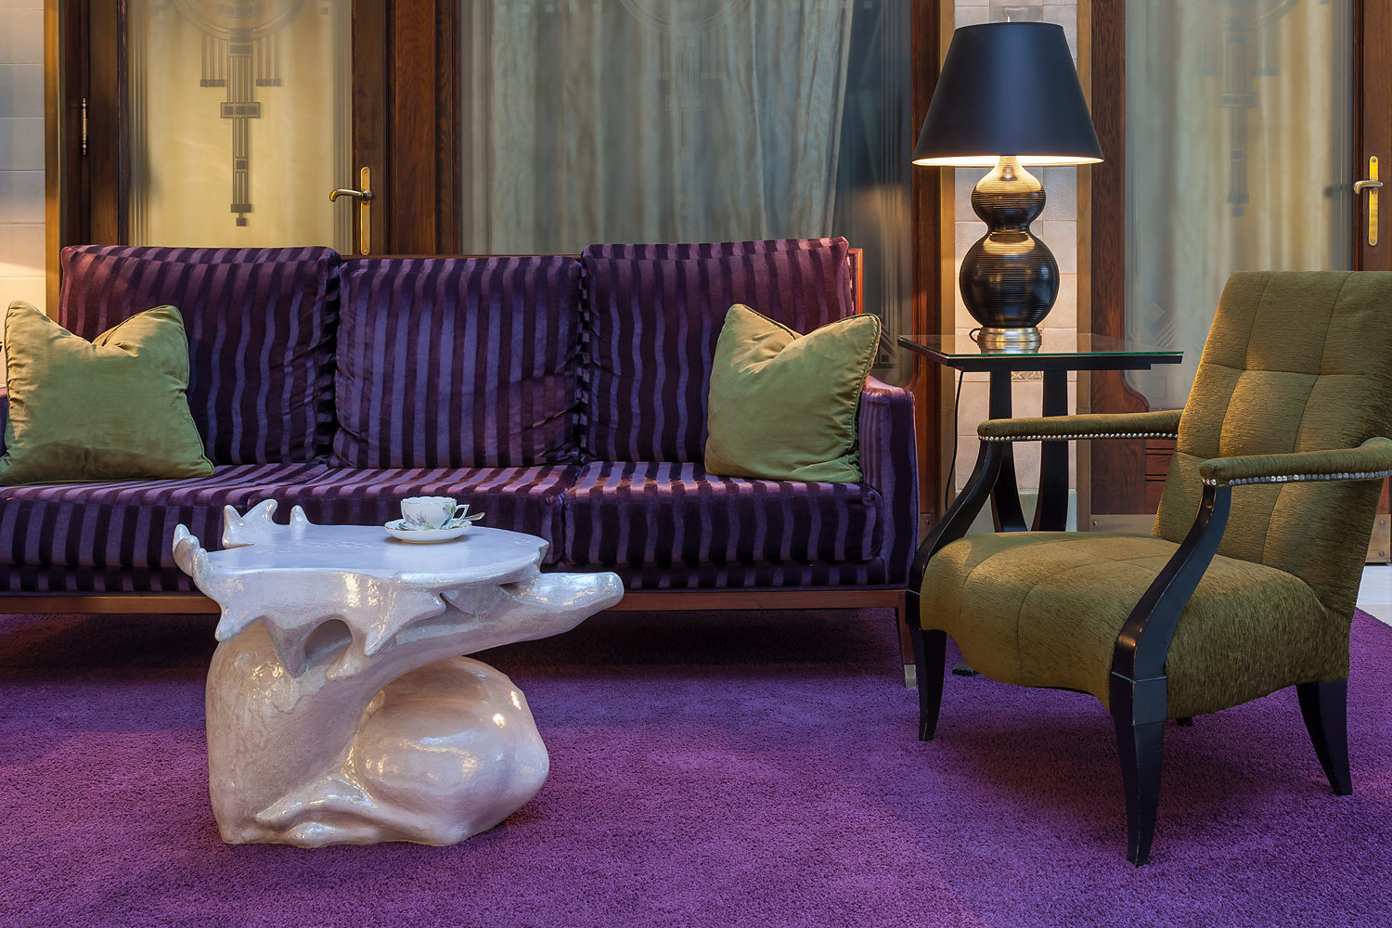
TAME DEER coffee table
The tactile, elegant deer is rich in details, with its antlers forming a fine arched crown. The piece inspires us to approach and remain within the herd for a peaceful moment.
The wakeful deer, looking backwards, shows continuous, unbridled attention. In a position of silence, its spiral shape lends a multi-detailed yet elegant form to the furniture.
The aim of the TAME DEER design concept was to create a handcrafted piece of furniture which becomes a focal point in the space. This formal language involves a very thin membrane that covers the deer, transforming the antlers into a functional tabletop.

The riveting figure of the deer creates a place for conversations in living room or garden. The TAME DEER coffee tables may be easily arranged as a herd by fitting them together. Two or more deer pieces can serve a larger number of people simultaneously.

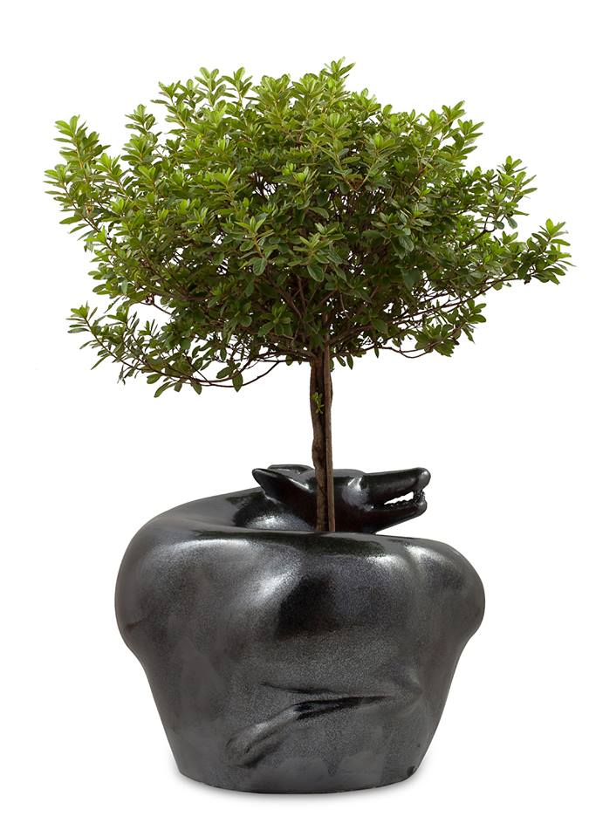
The TAME WOLF tries to defend his “territory” with a spiral movement, turning several times.
The aim of the design was to represent this continual spinning by some sharpening and blurring features of the surface. The spiral dynamics is expressed by means of blending the pointed and emphasized facial part into the blurred rear. This is a transition leading from the organic features into the pure geometrical ring shape.
The WOLF has a multifunctional purpose thanks to the hollow vault created by the method of production. The piece can be loaded with an air filter system and evaporator, or with a heating system. However, the center hole of the ring provides place for a hydrocultural pot. This function as a centered planter is also a way of paraphrasing the territorial defense instinct.

TAME comes in bright yet elegant colours: fiery red, rose alabaster, crystal graphite, moss green, sea turqoise, metallic bronze, antique bronze, old metallic, mother of pearl white, antique gold. In additon to these, TAME pieces can be ordered in any custom colour.
Made from frost proof glazed chamotte clay mass. FOX seat 55x60x45 cm, BEAR seat 45x55x55 cm, DEER table 68x52x45 cm and WOLF planter D=80cm, H=60cm. Weight: 40 – 75 kg /each.

ART OF TACTILE
TAME represents a niche in the world of furniture design. By the traditional yet novel use of ceramic in terms of its form, by its unique and refined shape it re-interprets the definition of tailormade furniture. The sophisticated sculptural forms of TAME furniture invoke the spirit of ancient functional sculptures and traditional and figurative furniture, carefully created by artisans.
Beside its function, animal shapes bring forth strong emotions by awakening our sense of longing for nature. A geometric shape from afar but the contour of an animal when stepping closer, we ourselves set it together with the related forms embedded in our imagination.
Appreciating TAME requires a set of senses: besides vision, the more subtle, invisible details are to be taken in through our sense of feeling. For the ultimate experience of its shape and material, we need to spend time with the object. Similarly to approaching tame wilds, first by cautiously drawing near, then by a reassuring touch, they open up to show their true nature.
TAME furniture is liked by all ages. Pieces installed so far are enthusiastically discovered by grandparents and grandchildren alike, surprising with one another with pointing out the hidden vertebra of the fox and the soft paws of the bear. Or gently stroking the soothing, protruding ears in the fox fur while passing by in a park.

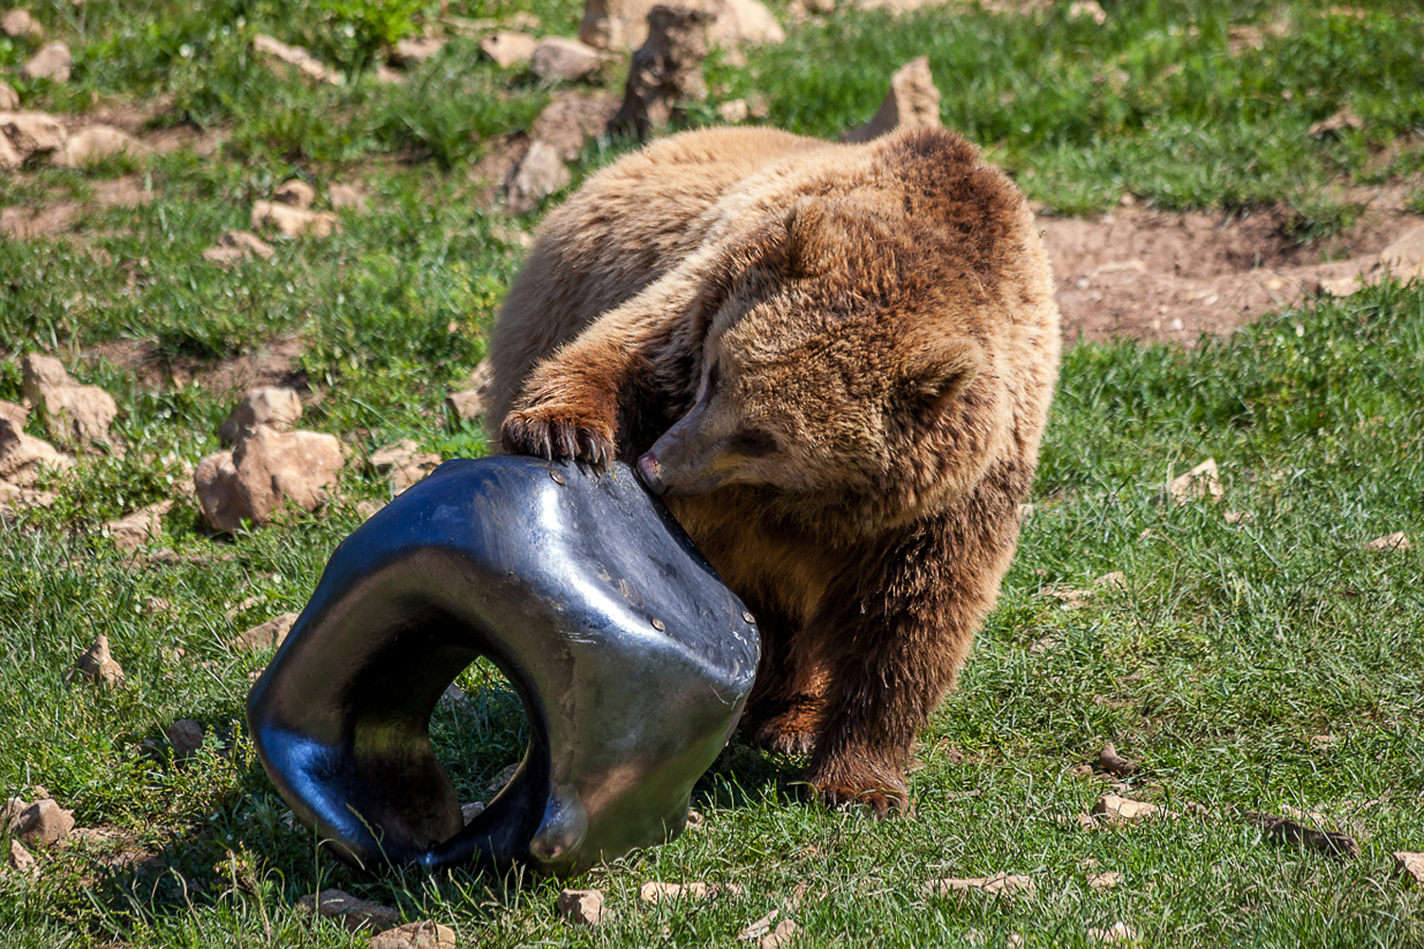
TAME BEAR LIMITED EDITION
Edit Szabo created her Traditional Limited Edition series TAME BEAR to exploit the technical possibilities of ceramics in attaining the highest quality. The limited series will consist of 12 unique pieces. Each piece will be created using a different open-firing technique with a traditional historical precedent. The goal of this limited-edition series is to keep a balance of traditional ceramic methods and contemporary impresses.

THE ART OF FLAMES AND ASHES
This delicate wood-fire technique allows for special firing effects. Flames saturated by acacia ash paint the surface of the glazed TAME BEAR. Here, the angles and direction of the flames, combined with falling ashes, highlight undetected details of its shape. In the last stage of the wood-fire process, the clay body transforms to a translucent and soft material responsive enough to take the chemical change from the acacia ash. Ultimately we used a temperature of 1320 C in the kiln.
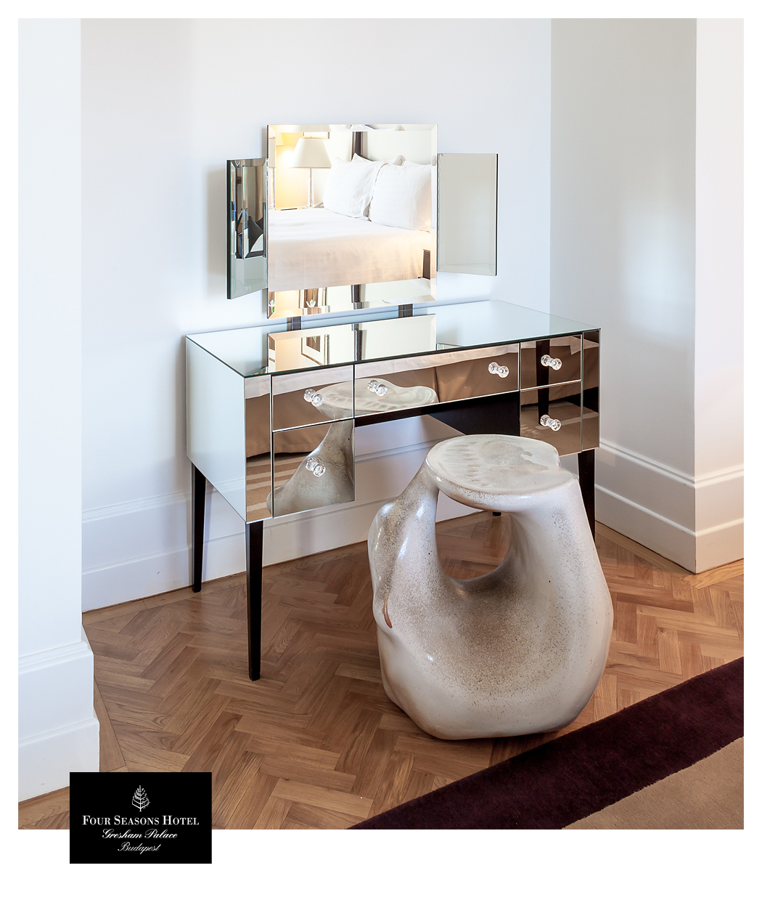
HOW TO TAME
The pieces that make up the TAME series are manufactured from durable, long-lasting chamotte clay mass using the traditional techniques of the Zsolnay Pyrogranite factory. The pieces are uncommonly long-lived furniture, even in the most extreme conditions. The archetypal forms were manually pounded into negative molds, later fired at high temperature from chamotte clay mass into exceptionally hard, durable, frost-resistant, water-resistant, chemically inert, UV resistant and easy to clean pieces. The furniture is hollow thanks to the method used to press their forms, making them light and easily arranged. They can be fixed to any foundation, and any form of electronics may be installed in their voids. They can also accomodate any type of heating, as piping can be installed inside their shapes. They meet the hygenic standards of bathrooms, and are easy to clean. They are ideal as resting places or heated (or cooled) seatings in spas, saunas and pools. Their formal language makes it possible to manufacture them from other materials, such as concrete, fibreglass, or artificial stone.

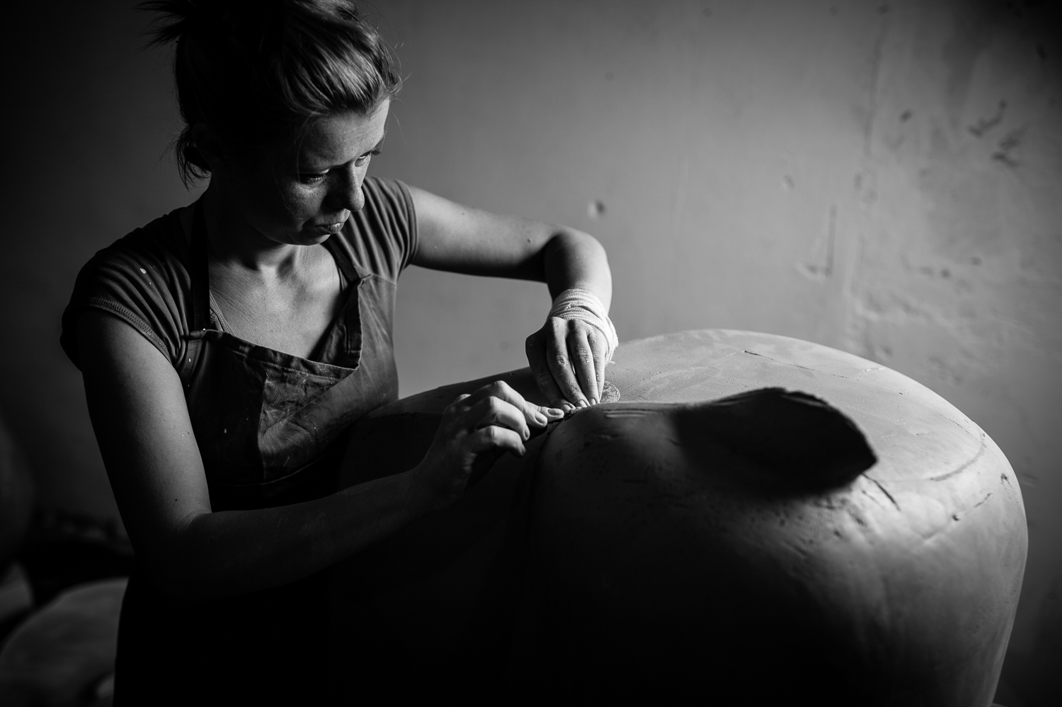
„I was born in Transylvania, home to thousands of bears live. You can easily bump into a bear anywhere, even in a city. In this mythical land everybody has a story of surviving an encounter with a bear. In my childhood I heard several exciting and terrifying stories about fights between humans and bears, which had become the iconic animals of this land. We went into the woods almost every weekend in summer to collect fruits in the undergrowth. Once, as I was picking raspberries, I lifted a branch and suddenly found myself face to face with bear, both of us eating the same fruit. Luckily nothing happened. Both the bear and I turned onto our separate paths.

My grandma lived in a small spa town in the mountains, where I would spend part of the summer. We would feed wild bear cubs there, which was very exciting. Every day at four o’clock, a mama bear brought her four cubs to town for us to feed them by hand with honey and sandwiches. We never had any trouble with them. It was a peaceful miracle.

On the other hand, I had a very sad experience with foxes in my childhood. There was an old custom in the village of my maternal grandparents, where hunters collected little fox cubs to rear them for their fur. Sometimes, in their little crowded cage, foxes were given some feathery chickens to help them grow. As a little child I often went to their cages to draw them as they waited for death.

Every year I spent a few weeks with my family in the woods by the small town where I was born. There were a few cottages in the middle of the forest, in the heart of the mountains. We would simply enjoy nature, doing nothing in particular but drawing and painting outdoors with my father. If we didn't watch out, the shepherd's dog would steal our food. These few weeks every summer were my closest experience with nature. Very early each morning a herd of deer and wild horses would pass right by the cottage where we stayed. I can still smell them in the fresh early morning air, I remember it so well. Sometimes I would go look at them. Every time, in their path, three deer males would stand out from the herd in front of me to protect their females. It was clear and straightforward, in peaceful silence.

Some time ago, I decided to make a series of figurative wild animal objects, which ultimately became functional products. One source of inspiration for the series was the presentation of nature in Lars von Trier's film "Antichrist," an exceptional example of visual storytelling. The wild animals in the forest symbolize human emotion and a narrative through their shapes, movements, and even their mere presence.”

Edit Szabo

